**Deployment of website on AWS EC2**

**Step 1: Login to the AWS with Aws account and launch AWS ec2 ami :**

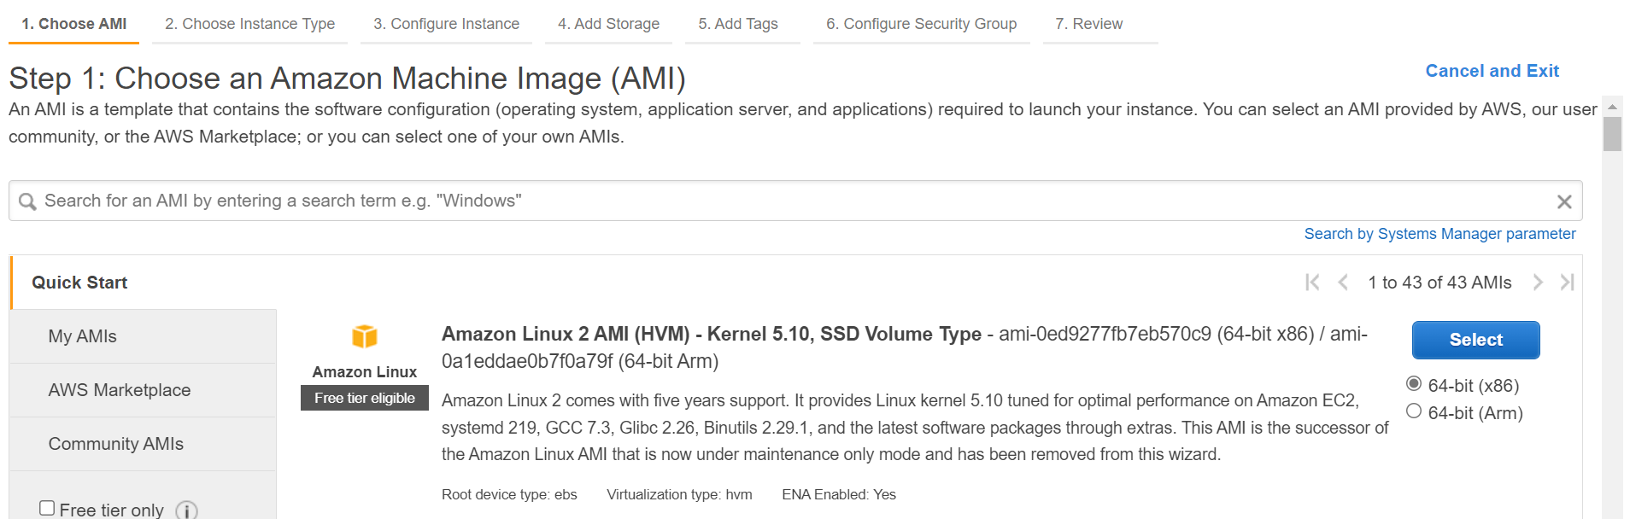

**Step 2: Do ssh on the Launched instance using putty:**

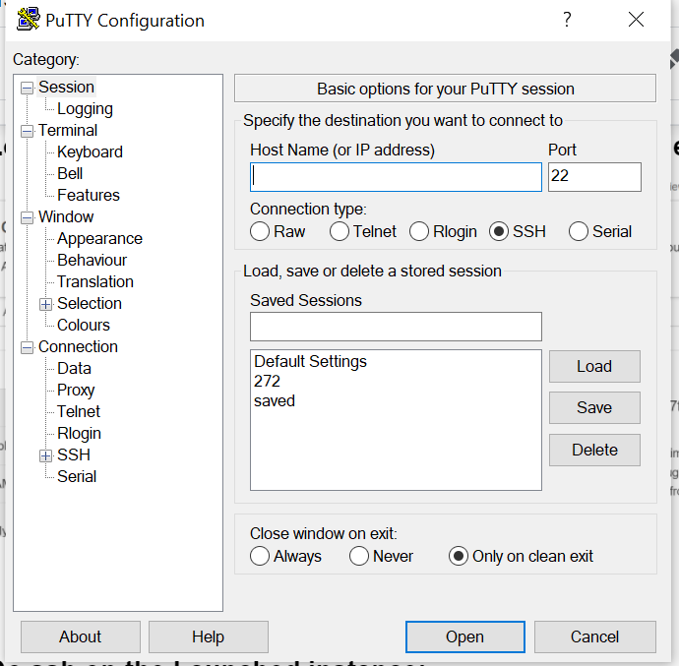

**Step 3: Run the following command**

curl -o- https://raw.githubusercontent.com/nvm-sh/nvm/v0.34.0/install.sh | bash

. ~/.nvm/nvm.sh

nvm install node

node -e "console.log('Running Node.js ' + process.version)"

Steps to install Git on EC2

sudo yum update -y

sudo yum install git -y

git version

**Step 4: Git clone the repo :**

Git clone https://github.com/gopinathsjsu/team-project-avenghers.git

**Step 5: Go to Backend folder and run:**

Npm install

**Step 6: Go to Frontend folder and run :**

Npm install

**Step 7 : Install pm2 for persistent process for node and react server:**

npm i -g pm2

**Step 8 : Run the following command:**

1)Go to backend :

pm2 start “npm run devStart”

2)Go to frontend:

pm2 start “npm start”

**Step 9: Access the website :**

http://<IPV4 of the ec2 instance>:3000